

# "Locker Login System - Verifying Password"

# "SMART LOCKER SYSTEM"

## TEAM G

By: Billona, Ezekiel

Mamerto, Mark Nelson Pontay, Ashley Salanatin, Nathaly Pearl



## TABLE OF CONTENTS

1. **SCENARIO/BACKGROUND**
   1. Scenario
   2. Current Problems
   3. Target Beneficiaries or users of the system

## OBJECTIVES

## SCOPE AND LIMITATIONS

## RESULTS AND DISCUSSIONS

## CONCLUSION AND RECOMMENDATION

1. **APPENDICES**



## SCENARIO/BACKGROUND

Lockers is a narrow storage compartment for storing clothing or other personal items. It is commonly used on university campuses for students to safely store their clothing or other personal belongings.

A student locker tends to contain things that are valuable to them, like pictures, books, homework, and other belongings they may need. However, with an increasing number of students on campus, managing locker access and usage has become a difficult task. A locker is supposed to be a safe box to store items without having to worry that it may be stolen or ruined.

The proposed system would implement a better locker login system that will verify students' TUPM ID and password before granting locker access. A more secured locker is undoubtedly the greatest benefit that comes with installing lockers for universities.

## PLACE TO IMPLEMENT

* The proposed system would be implemented inside the Technological University of The Philippines.

## CITE THE DEVICES TO BE UTILIZE

* "start=led_display.exe" EXAMPLE IN EMU8086

It will serve as counting device of how often students enter their passwords incorrectly.

## OPERATION

The proposed system will monitor locker usage patterns by tracking login date and time (operation), providing insights on peak usage times and trends to optimize locker availability and management on campus.

The Proposed system will also include input and output operations for students to enter their TUPM ID and password, which the system will verify before granting access to the lockers. This ensures that only authorized students have access to the lockers, which improves security and lowers the risk of theft or vandalism. The system will also be able to reset passwords for students who have forgotten their login credentials, allowing them to immediately access their lockers



## SPECIFIC OBJECTIVES

▪ The proposed system is designed to create a simple login system for lockers that verifies a students' user ID and password

* The proposed system is mainly to share and discuss a simple "locker system" for everyone.
* To accomplish the program within a certain time.
* to develop a well function program.

1. **SCOPE AND DELIMITATIONS**

The general intent of this study is to create a safe box to store items without having to worry that it may be stolen or ruined.

The proposed system is delimited to weight inputs up to 125 only. Any input weight greater than this value will result in an incorrect output. Additionally, the program only accepts weight input in whole numbers, decimals are not supported.

1. **RESULTS AND DISCUSSION**
2. Screen shots of output

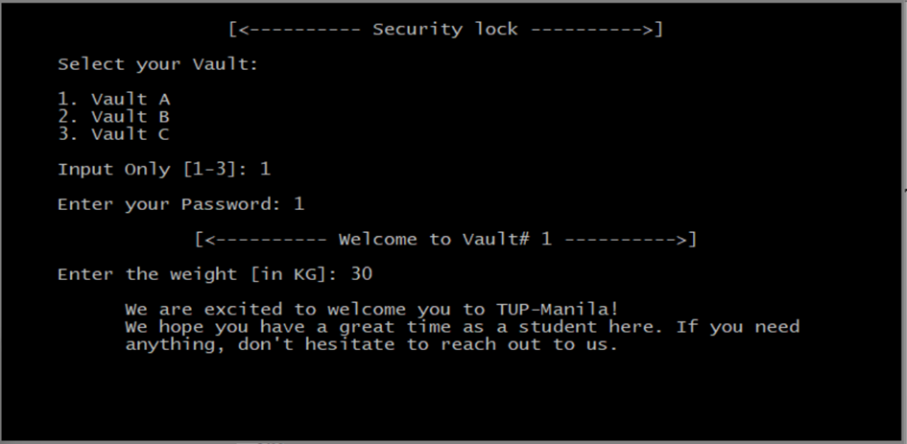

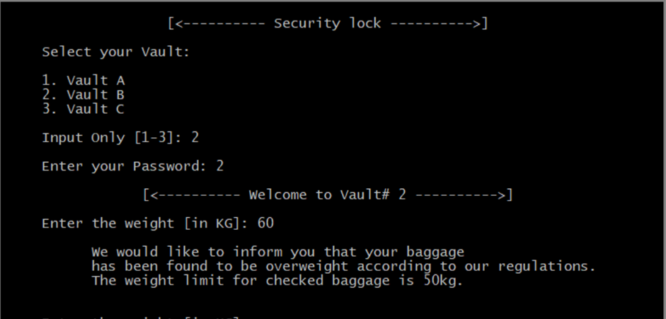

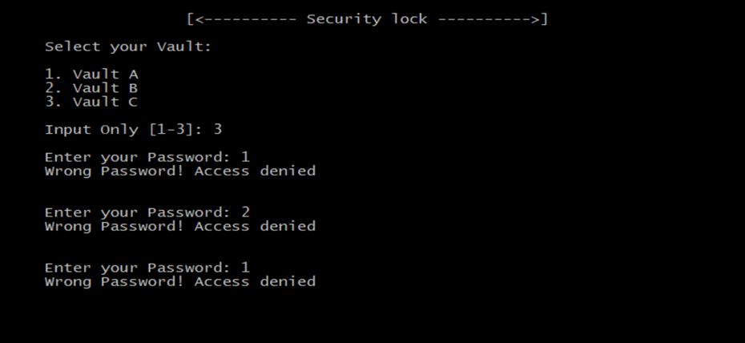

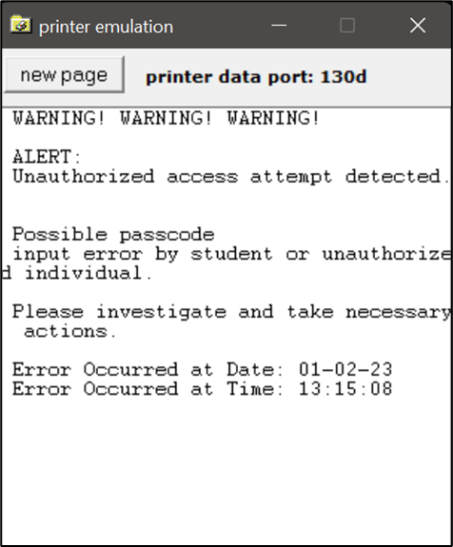

## JOB DISTRIBUTION

|  |  |  |
| --- | --- | --- |
| NAME | JOB DISTRIBUTION | E-Signature |
| **Billona, Ezekiel - Leader** | Developer/Programmer, Researcher, Quality assurance tester |  |
| **Mamerto, Mark Nelson** | Developer/Programmer, Researcher, Quality assurance tester |  |
| **Pontay, Ashley** | Developer/Programmer, Quality assurance tester |  |
| **Salanatin, Nathaly Pearl** | Quality assurance tester, Researcher, Documentation, Video Editing |  |

**Conclusion and Recommendation**

"Smart locker system" is a code is written in the Assembly language for the emu8086 architecture and appears to be a program for a vault security system. It initializes data for messages and passwords for three vaults, entry for a weight, date and time, and warning messages. It then displays a title and prompts the user to select a vault and enter a password. If the password is correct, the user is granted access to the vault. If the password is incorrect, he program counts the number of attempts and locks the vault after three failed attempts. It also displays an overload prompt if the entered weight exceeds 50 kg. The program finishes with the posting of a farewell.